` 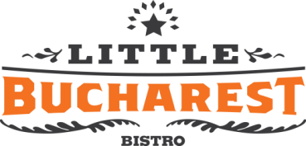

Contract pentru petreceri private

Prezentul contract se semneaza intre Dl. Branko, Little Bucharest Bistro (3661 N. Elston Ave.) si

Nume si Prenume :___________________________________ Telefon:__________________________

Adresa:_________________________________ Email:______________________________________

Numar invitati: _____________________ Pret/invitat: _____________________

Petrecerea va avea loc pe data : _________,_________,_________

Aperitive: Ciorbe: Garnitura:
Platou (3 tipuri de Ciorba de Vacuta Cartofi Taranesti
salam, rosii, castraveti, Ciorba de Burta Cartofi Pai
masline, branza Feta) Ciorba de Perisoare Piure de cartofi
Chiftele Ciorba de Borscht Cartofi rosii la cuptor Salata de Vinete Salata De Varza Icre
Felul principal: Desert:
Sarmale Piept de Pui la Gratar Placinta cu Mere
Mititei Pui crocant la cuptor Dobosh $4 extra
Peste Tilapia Skirt steak Savarine
Tochitura moldoveneasca Ceafa Clatite
(cu sau fara sos)
Schnitzel (porc sau pui) Cafea americana sau Ceai cald
Toata mancarea va fii servita la platou.
Mentiuni speciale:

Little Bucharest Bistro
3661 N. Elston Ave. Chicago IL, 60618
Tel: (773) 604-8500 Fax: (773) 293-7604
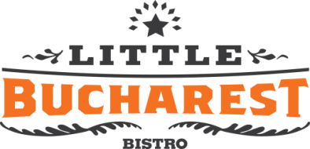

The Regular Open Bar Will Serve:
Martel, Courvoisier, Jack Daniels, Amaretto, Irish Cream, Kahlua, Peach Schnapps,
House: Whiskey, Vodka, Rum, Tequila and Gin, Romanian Red and White Wine, Heineken, Becks, Miller Lite, MGD
Premium Drinks: $_______________
____________________________________________________________,
NO BOTTLES WILL BE PLACED ON THE GUESTS TABLES.
ALL DRINKS WILL BE AVAILABLE AT THE BAR OR FROM WAITRESS.
NO OUTSIDE FOOD OR ALCOHOL IS ALLOWED!
Decorations:
Little Bucharest Bistro can provide the following decorations, at an additional cost:

Flowers_________________________ Balloons__________________________

Chair covers WILL NOT be supplied by Little Bucharest Bistro, you must bring your own.
If you bring decorations, we will set them up for you.
Music:
LIVE MUSIC:_____________________ DJ_______________________________

A 15-20% gratuity will be added to the total of the bill

Total Cost For Guests: $______________________________

Additional Costs: $______________________________

Music $______________________________

Gratuity $_______________________________

DEPOSIT: $_______________________________

TOTAL COST OF PARTY $_______________________________

Branko Podrumedic ___________________ Party Host______________________
Owner – Little Bucharest Bistro

Date____________________________
Little Bucharest Bistro
3661 N. Elston Ave. Chicago IL, 60618
Tel: (773) 604-8500 Fax: (773) 293-7604

